KPOT-PRO_V02

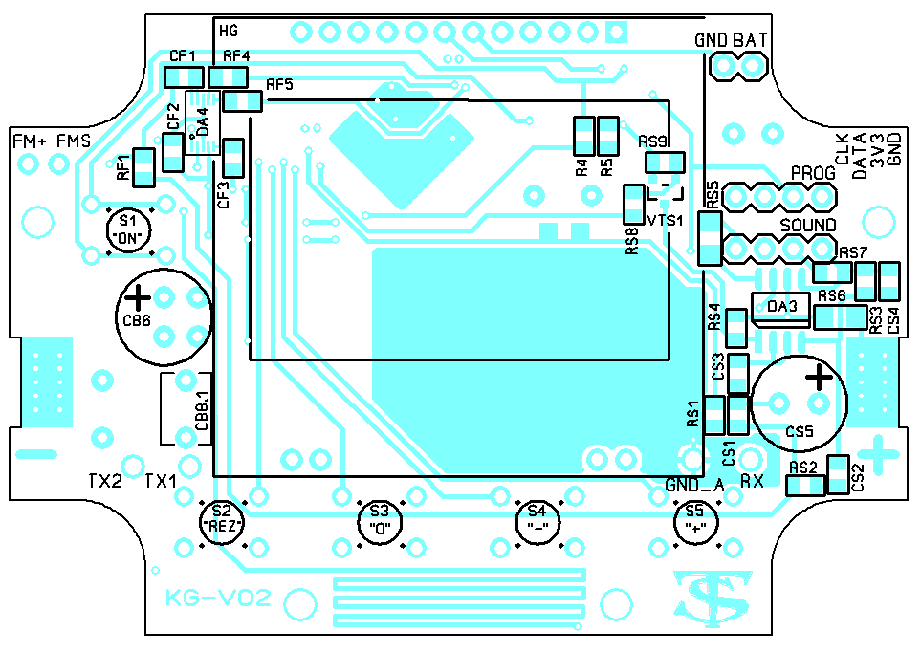

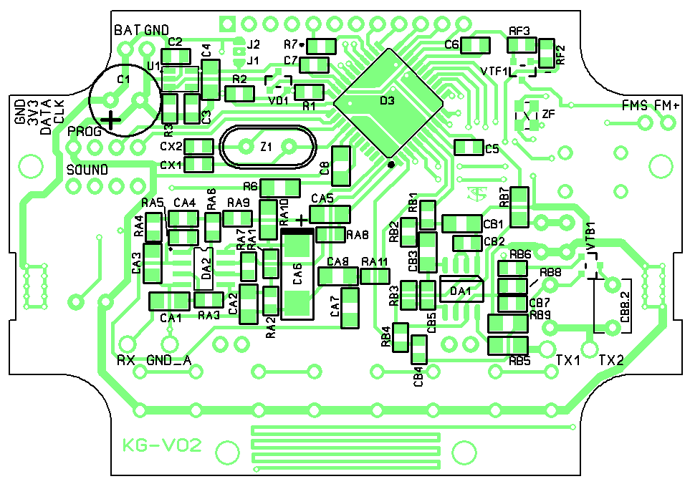
Доработка платы:
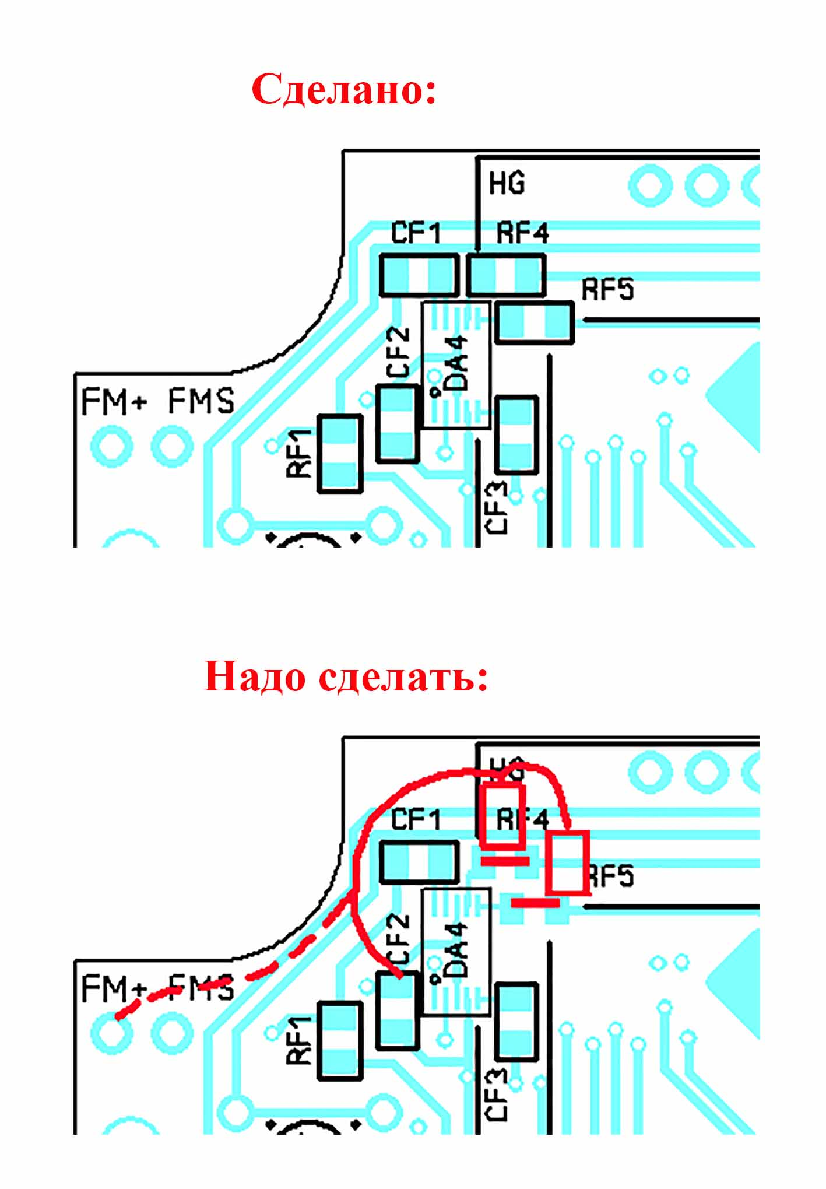

KPOT-PRO_V02
Перечень элементов
Учитывайте текущие изменения номиналов.

RefDes | Type | Value | Description
C1 | C8^5_3^5-08 | 1000.0
C2 | C0805 | 100n
C3 | C0805 | 10n
C4 | C_1206 | 2.2
C5 | C0805 | 100n
C6 | C0805 | 100n
C7 | C0805 | 100n
C8 | C_1206 | 10.0
CA1 | C_1206 | 10n
CA2 | C_1206 | 10.0
CA3 | C_1206 | 33n
CA4 | C0805 | 200p
CA5 | C_1206 | 10n
CA6 | POLCAPTANT(D) | 220.0
CA7 | C_1206 | 300p
CA8 | C_1206 | 2200p
CB1 | C_1206 | 2200p
CB2 | C0805 | 1.0
CB3 | C_1206 | 10n
CB4 | C0805 | 100n
CB5 | C0805 | 22p
CB6 | C8^5_3^5-08 | 1000.0
CB7 | C0805 | 1.0
CB8.1 | C_4.5X6L5 | 100n
CB8.2 | C_4.5X6L5 | 100n
CF1 | C0805 | 1.0
CF2 | C0805 | 100n
CF3 | C0805 | 100p
CS1 | C0805 | 22n
CS2 | C0805 | 10n
CS3 | C0805 | 1.0
CS4 | C0805 | 22p
CS5 | C8^5_3^5-08 | 1000.0
CX1 | C0805 | 15p
CX2 | C0805 | 15p
D3 | ATXMEGA32 | ATXMEGA32A4U-AU
DA1 |  | CSC8002B
DA2 |  | MCP6022
DA3 |  | CSC8002B
DA4 | QN8027 | QN8027
H1 | 128X64
J1 | JR1.5
J2 | JR1.5
R1 | R0805 | 1K
R2 | R0805 | 10K
R3 | R0805 | 10K
R4 | R0805 | 5K1
R5 | R0805 | 10K
R6 | R_1206 | 8R2
R7* | R0805 | 51
RA1 | R0805 | 3K
RA2 | R0805 | 3K
RA3 | R0805 | 3K
RA4 | R0805 | 620*
RA5 | R0805 | 51K
RA6 | R0805 | 10K
RA7 | R0805 | 10K
RA8 | R0805 | 430
RA9 | R0805 | 430
RA10 | R_1206 | 8R2
RA11 | R0805 | 10K
RB1 | R0805 | 10K
RB2 | R0805 | 10K
RB3 | R0805 | 100K
RB4 | R0805 | 10K
RB5 | R_1206 | 2R
RB6 | R0805 | 1K
RB7 | R_1206 | 1
RB8 | R0805 | 10K
RB9 | R_1206 | 1
RF1 | R0805 | 10K
RF2 | R0805 | 1K
RF3 | R0805 | 10K
RF4 | R0805 | 10K
RF5 | R0805 | 10K
RS1 | R0805 | 5K1
RS2 | R0805 | 5K1
RS3 | R0805 | 100K
RS4 | R0805 | 10K
RS5 | R_1206 | 0-2R
RS6 | R_1206 | 2R
RS7 | R0805 | 0-2R
RS8 | R0805 | 1K
RS9 | R0805 | 100K
S1 |  | ON
S2 |  | REZ
S3 |  | 0
S4 |  | -
S5 |  | +
U1 | SOT23-5_2 | TPS79933
VD1 | BAV70
VTB1 | IRLML2502 | IRLML0060
VTF1 | IRLML6402 | IRLML6402
VTS1 | 2N7002 | 2N7002
X1 | STICKS4 | PROG
X2 | STICKS4 | SOUND
X3 | STICKS1 | TX1
X4 | STICKS1 | TX2
X5 | STICKS1 | RX
X6 | STICKS1 | GND
X8 | STICKS2 | BAT
Z1 | CRYSTAL | 16MZh
ZF | KX-7 | 24MZh

